Order Of Service

Singing: Psalm 91—CW page 100

Reading: Psalm 10

Opening Hymn: TLH 658

Reading: I Corinthians 7:32-40

Request Hymn: CW Supplement 769

Reading: Matthew 27:45-56

Sermon Hymn: TLH 613

Sermon Text: Luke 9:49-56

On To Jerusalem

Prayer

The Apostles’ Creed, TLH page 12

Holy Communion

The Lord's Prayer

The Blessing

Closing Hymn: TLH 10

* * * * * * * * * * *

Bible Study: Lambs: The Wind
Sheep: Philippians 2:1-11
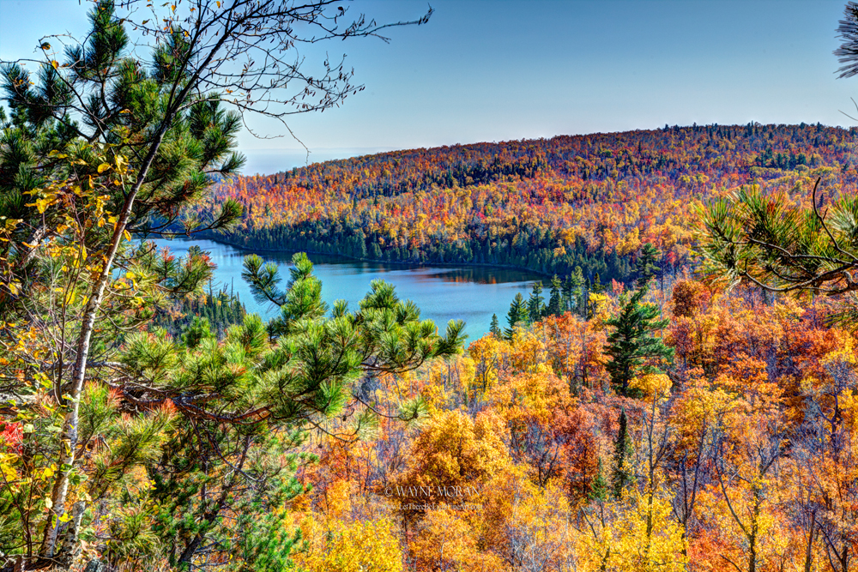

Fall Scene On Lake Superior

Water
Of
Life

24 October 2021

W A T E R O F L I F E

Independent Christian Church—Conservative Lutheran Doctrine

Worship Service: 9:30 a.m. Bible Study: 10:45 a.m.

Larry Cooper, Pastor E-Mail address:
111 N. Ridge Road lcooper@wateroflife.cc
Coon Valley, WI 54623 Web Site:
www.wateroflife.cc

* * * * * * * * * * * * * * * * * * * * * * * * * * *

Sermon Text: Luke 9:49-56

On To Jerusalem

* * * * * * * * * * * * * * * * * * * * * * * * * * *

49 And John answered and said, Master, we saw one casting out devils in thy name; and we forbad him, because he followeth not with us.
50 And Jesus said unto him, Forbid him not: for he that is not against us is for us.
51 And it came to pass, when the time was come that he should be received up, he stedfastly set his face to go to Jerusalem,
52 And sent messengers before his face: and they went, and entered into a village of the Samaritans, to make ready for him.
53 And they did not receive him, because his face was as though he would go to Jerusalem.
54 And when his disciples James and John saw this, they said, Lord, wilt thou that we command fire to come down from heaven, and consume them, even as Elias did?
55 But he turned, and rebuked them, and said, Ye know not what manner of spirit ye are of.
56 For the Son of man is not come to destroy men's lives, but to save them. And they went to another village.

